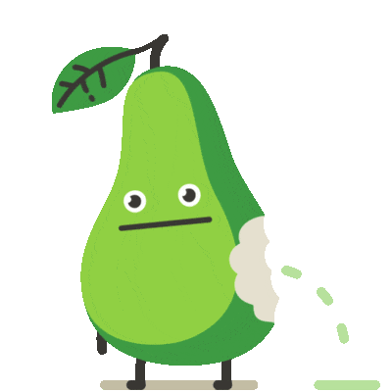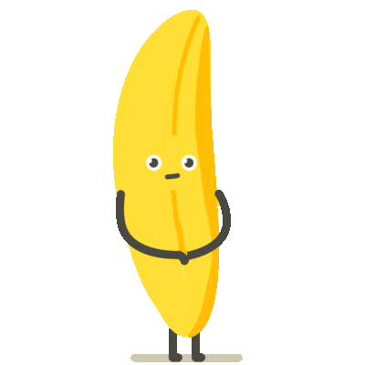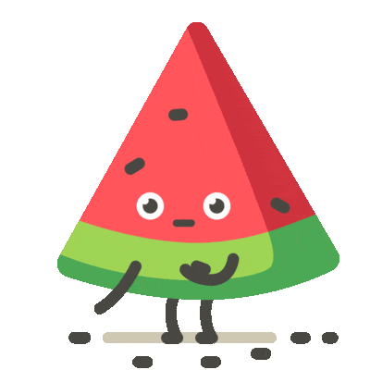

School Meal Information

Every day we offer a choice of a hot meal or a vegetarian main meal with dessert or fruit. As well as this, Jacket potatoes are available daily with a choice of toppings or a sandwich option with a selection of fillings, these choices also come with a dessert or fruit.

School dinners for Foundation Stage and KS1 pupils (years 1 & 2), are currently free under the ‘Universal Free School Meal’ government initiative.

School dinners for KS2 (years 3, 4, 5 & 6) should be paid at the time of booking.

All meals are to be ordered via our online payment system, School Spider. Payable meals must be paid for at the time of order and cost £3.00 per day. Orders need to be made before 8:30am on the day required, but can be ordered for a day, a week or even a term at a time. Please note, jacket potato orders must be made at least 24 hours in advance (no later than 8.30am the day before requirement) as we need to order these from our supplier. Please speak to the school office if you have any queries.

If for any reason a meal has not been booked for your child, please contact the school office on 01626 772901, before 9:00am, so a meal can be ordered from our supplier.

If your child has eligibility for a ‘free school meal’ or if you wish to receive information on how to apply for ‘free school meals’, please speak to our office team on 01626 772901 or admin@hazeldown.devon.sch.uk.

With many thanks

Hazeldown Primary School

